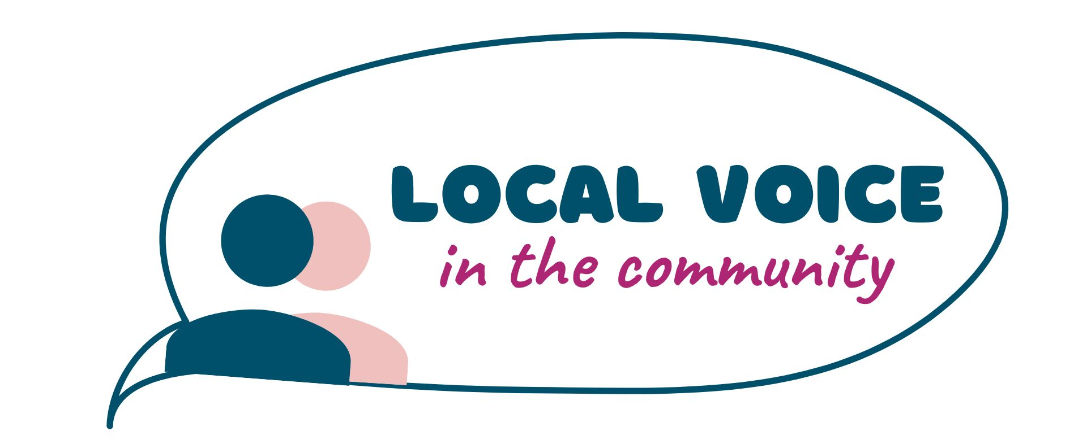


Board Member Recruitment Pack

2025
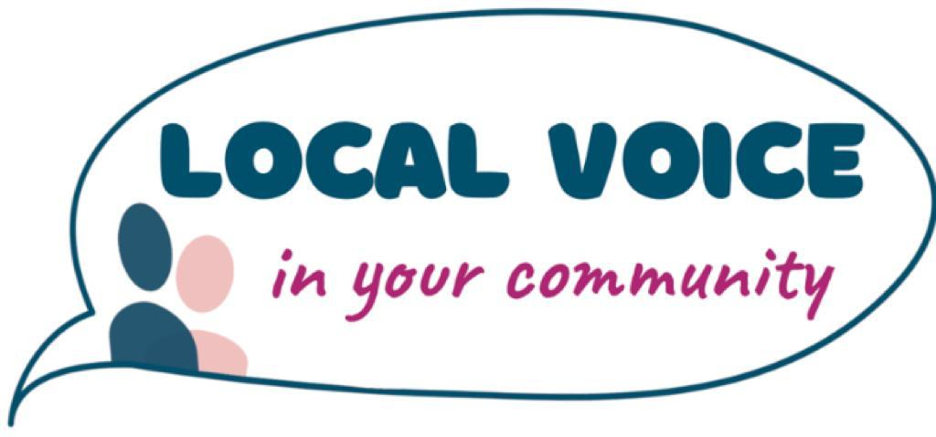

Local Voice in the Community
Board Member
Recruitment Pack
Local Voice
Board Recruitment

Introduction
Local Voice is the first user led organisation to engage and support resident voice in public policy through a recognised evidence-based community insights data system.
We support local residents to gather and analyse community insights and work together with stakeholders -including local Healthwatch, NHS trusts, primary care alliances, commissioners, local authorities and the voluntary sector- to design services to create equal outcomes for everyone.
We bring local people's voices into all aspects of strategy, policy-making, de/commissioning and quality improvement by providing a solid evidence base of user needs and experience. In this way, we empower policymakers and service providers to better understand local population health and the different needs of specific groups, in order to design solutions that genuinely respond to everybody's needs, leaving no-one behind.
Role
Local Voice is looking for Board members who will have key responsibility for the overall business management and performance of the charitable company ‘Local Voice’.
We are interested in receiving applications from candidates who have proven experience gained in a professional, personal or voluntary capacity in one or more of the following specific areas:
Business Development
A track record of developing a social enterprise, fundraising and maximising sustainable business opportunities. An understanding of business planning and strategy would also be helpful.
Research and/or social marketing
Able to provide leadership around robust research and social marketing techniques within a charitable company along with some expertise in evaluation and impact assessment. An ability to analyse complex information; synthesizing and making effective use of data and research evidence highly desirable.

Communications, PR and media
Able to support Local Voice’s communication, PR and media strategy by providing expertise and a track record of delivering such strategies within a comparable environment.
Finance
Demonstrable experience of managing budgets in excess of £150,000 within a highly complex environment. Ideally you will understand how to build a financially sustainable organisation that can deliver good value for money probity and financial accountability.
Governance
Expertise in ensuring that the Board understands its specific role around governance. You will support the organisation to ensure accountability and transparency and to deliver our business objectives efficiently, effectively and sustainably in line with good governance/Nolan principles and recognised best practice.
User Engagement
Experience of using a broad range of patient and user engagement techniques that have impacted on decision-making. Ideally able to advise the Board on how patient/user experience can be gathered and used effectively.
To fill these roles you will have leadership experience in the voluntary and community sector, public sector or business environment, a passion for improving health and social care services and a genuine commitment to engaging all sections of the community.
The Co-Chairs and Board Members will have legal responsibilities as directors of a the Charitable Company (Charity Number 8786829, Company Number 1158809), and will be accountable for the discharge of Local Voice statutory responsibilities.

Background
It is essential that Local Voice has the right attributes to be effective and successful. In order for this to be achieved, the recruitment process for the Board has three key aims:
- To appoint members who have the right skills and experience to be capable and effective in their role.
- To recruit members who possess an attitude and approach that is in line with the core principles and aims of Local Voice.
- To create a membership that is from a diverse range of backgrounds and is as representative of (or is able to represent) the local population as far as possible .
Key Responsibilities
The Board will have responsibility for the governance of Local Voice.
The Board’s key role is to direct and control the work of the organisation:
- to determine strategic direction and policies;
- to ensure the activities of Local Voice reflect the diverse communities, not just the views of majority groups or the most high profile issues;
- to establish and oversee control and risk management arrangements;
- to ensure that Local Voice achieves its aims and objectives; and
- to oversee ‘Operational Management’ and ensure the implementation of Board policies. These will be delegated to the Chief Executive and the staff team on a day-to-day basis.
The key responsibilities and accountabilities of the Board are:

Leadership and direction
- Define the vision and values of Local Voice and ensure that these are realised and upheld.
- Define the direction of the organisation’s business, services and activities.
- Ensure clear accountabilities and communication within the organisation and monitor the activities of Local Voice.
- Maintain a clear public, patient, service user, carer and wider community focus.
- Create a positive environment that fosters constructive challenge to assumptions about the organisation.
- Review Board composition, performance and succession planning regularly.
- Appoint (and if necessary, remove) the independent Chair(s).

Risk Management
- Oversee a framework for the identification, management and review of risks, including agreeing risk.
- Contribute to the review and evaluation of strategic risks, receiving regular reports on these and emergent risks.
- Ensure that a positive culture of managing opportunities, threats and uncertainties is embedded throughout the organisation.
- Determine policies and decisions on all matters that might create a significant financial or other risk to Local Voice, or which raise material matters of principle.

Performance monitoring
- Regularly review and monitor performance and quality in relation to plans, budgets, controls and decisions.
- Obtain and consider performance and quality information in relation to public, patient, service user and carer feedback and benchmark against comparable organisations and activities.

Probity and integrity
- Approve each year’s accounts prior to publication.
- Obtain assurance that Local Voice affairs are conducted lawfully and in accordance with generally accepted and specific standards of reporting, performance and probity.
- Ensure that Local Voice complies with all relevant regulatory and statutory requirements.

Transparency and openness
- Be accountable to service commissioners
- Publish an Annual Report and Accounts each year, highlighting priorities, progress and key issues.
- Establish a policy for communicating with, and involving, public, patients, service users, carers, partners and other stakeholders about its work and performance.

Management arrangements
- Ensure there are appropriate policies and systems in place to recruit, develop, retain and remunerate staff.
- A minimum of four Board meetings will be held each year.
- Set and review the Board’s Regulatory Documents, including voting rights and quorum.

Strategic development
- Review the key strategic aims and determine the strategic objectives and outcomes required
- Drive the development of the strategic plan, providing constructive challenge and ensuring its effectiveness
- Approve an annual operational plan, budgets and financial arrangement that support the achievement of the strategic and operational plans
- Establish a framework for approving and regularly reviewing policies and plans to achieve the objectives of the organisation
- Ensure that all assets are managed efficiently and effectively, and that capacity is properly utilised, so as to maintain long term viability and sustainability of Local Voice

Person Specification
We will appoint Board Members who can demonstrate skills and competencies in relation to one or more of the six bullet points specified above. However, against these specific requirements we would expect every Director to satisfy the generic person specification below:
Leading Local Voice
You will have a strong leadership background and an appreciation of the fundamentals of good governance. You will be able to support the Chair(s) and Chief Executive to translate organisational vision into practical implementation plans.
Managing Local Voice
You will understand the policy context in relation to the wider health and social care system. You will have the requisite skills to develop and manage effective relationships with key partners and stakeholders in order influence decision-making at the highest level and contribute to improved services and outcomes for local people.
Engaging the community
You will support the Chair and Chief Executive to engage with the local communities and represent the views of local people and the community at relevant meetings where appropriate.
Key knowledge/skills
You will be a highly effective communicator, and will possess a comprehensive understanding of the importance of safeguarding, teamwork and the equalities and diversity agenda. You will be able to assimilate feedback and local intelligence, including complex data sets in order to inform business planning and core activities.
Commitment
We anticipate the time commitment to be up to one day a month. All out of pocket expenses and travel etc. will be reimbursed in line with good practice.
Training
Board members are encouraged to identify personal training and development needs, and seek opportunities for development, attending training events as required. Specific training will be offered which is relevant to the role of the Local Voice Board members.
Selection
The best way of getting a representative group of people together is to appoint them. It is important for the success of the organisation that the Board should have the range of skills and expertise to establish and run a successful organisation. In addition an appointment method can specifically target and take account of demographic variations in a locality to address diversity and representativeness issues.
The procedure for assessing applicants will be transparent so that potential members are aware of and have confidence in the process.
Selection will be made by the Board. They will assess email or paper applications by comparing the completed application forms to the role and experience requirements using a points based scoring system with rating agreement between members.
Shortlisted candidates may be asked to attend a short informal interview.
After identifying successful candidates through the recruitment process, Disclosure and Barring Service checks will be made. The cost of these checks will be met by Local Voice.

Job Outline
Post Title: Local Voice Board Member

Responsible for: Acting in the capacity of Director under the Companies Act, and as a Charity Trustee you will contribute to the strategic aims of Local Voice, ensuring necessary financial and human resources are in place for the organisation to achieve its objectives, and devise robust systems of risk control and performance management.
Purpose of Job
To ensure Local Voice is managed efficiently, effectively and in line with its constitutional and statutory obligations, its code of conduct and best practice.

Main Responsibilities and Key Result Areas

- Working with the other Board Members of Local Voice to appoint the Chief Executive and Company Secretary.
- To participate in setting, implementing and monitoring Local Voices corporate objectives and core values.
- To monitor the performance of Local Voice to ensure compliance with constitutional, statutory, regulatory and contractual obligations, and to ensure that a sound financial position is maintained.
- To receive, read and consider reports and question these where necessary to ensure that decisions are well founded.
- To ensure that decisions taken by the Board are in the best interest of Local Voice and its legal and moral responsibilities are met.
- To attend Board meetings, committee meetings, working groups and training events and to participate in discussions and decision making on a regular basis.
- To offer advice and expertise to the Board and its committees.
- To commit to Local Voice’s approach to valuing diversity and equal opportunities through its service delivery and employment.
- To contribute to, abide by, and take collective responsibility for decisions by the Board.
- To undertake special tasks and/or responsibilities set by the Board or one of its committees, including representing Local Voice at conferences, seminars and special events.
- To declare any relevant personal, professional or commercial interests in any matters being discussed by the Board.
- To respect the confidentiality of information, where its release would compromise the interest of Local Voice.

Person Specification
Post Title: Local Voice Board Member
Note: E denotes essential / D denotes desirable
Skills |  | E/D
- Members need to be good communicators and be capable of playing an active role at regular meetings and contribute to discussions informing policy decisions.  - Members will be communicating with a range of different individuals from commissioners to members of the public, and must be willing to engage with them all.  - Members will play a lead role in determining how Local Voice’s budget is spent, so it is vital to have the financial awareness to do this  - responsibly.  - Members should have good analytical skills and awareness, and  understanding of research and research costs, in order to identify gaps in  public feedback and the provision and quality of local care services. |  | E  E  E  D

Knowledge | E/D
- Members should have an awareness of health and social care issues and an understanding of the importance of public involvement in these issues.  - Members are public representatives so they should have a good idea of what is expected from a position of civic responsibility.  - Members should have some knowledge of health and/or social care services.  - This could come from personal experience or a previous paid role.  - Members will also need strategic awareness to make decisions in the best  - interests of Local Voice in exercising its functions. | E  E  E  D

Experience | E/D
- Members should have proven communication and people skills and be able to demonstrate this with their experience.  - It is highly desirable for members to have had experience of public representation, particularly in health and social care. This may be as a representative of a service user group or acting as an advocate.  - Board members will be responsible for overseeing work on reports and shaping projects, so some experience of project management will be useful.  - Members will need to be active in their communities, so a track record of previous community activity is desirable. | E  D  D  D

Special Requirements & Environmental Factors | E/D
- Members are tasked with acting in public interest, and should therefore be public spirited and committed to the principle of championing the public’s interests in health and social care.  - Members need to be open-minded and inclusive; Local Voice will be tasked with engaging and representing the entire spectrum of the local population.  - Members need to have an active interest in how public involvement can shape health and social care services and have the desire to promote it. | E  E  E

Application to join the Board of Local Voice

Please tick one of the boxes below, to indicate the particular specialism you would bring to the Local Voice Board.

Finance
Governance
Business Development
Market research and/or social marketing
Communications, PR and media
Citizen Engagement

Your details:

Name:
Organisation (if applicable):
Address:
Telephone:
Email:

Reference 1 details:

Name:
Address:
Telephone:
Email:

Reference 2 details:

Name:
Address:
Telephone:
Email:
Please send this form with a copy of your CV, and a personal statement of no more than 2 sides of A4 detailing how you meet the person specification criteria for the post, and stating why you want to become a member of the Local Voice.
This form, and all supporting documents should be sent to info@localvoice.org.uk.
.

